Spatial Characterization of Protein Distribution in Muscle Spindles

Essabella Adjoa Scott
52427816
Supervisors: Ekkehard Ullner, Mamen Romano & Guy Bewick
Word Count: 3702

Contents
Figures and Tables 4
Abstract 7
1 Introduction 9
1.1 Background 9
1.1.1 Skeletal Muscle and Muscle Spindle 9
1.1.2 Intrafusal and Extrafusal Muscle Fibre Organization 10
1.2 Proteins of Interest 11
1.3 Project Objectives 12
2 Literature Review 13
2.1 Nuclear Envelope Proteins and Localization in Muscle Fibres 13
2.2 Imaging and Computational Approaches 13
2.3 Previous Work and Present Focus 14
3 Data 15
3.1 Image Data & Structure 15
3.2 Image Pre-processing and Intensity Adjustment 16
4 Methods 18
4.1 Main Pipeline 18
4.2 Nuclei Segmentation (DAPI Channel) 19
4.2.1 Preliminary Analysis of Protein Spatial Distribution 20
4.3 Benchmarking Neural Networks with MNIST Dataset 21
4.4 Deep Feature Extraction Using CNNs 22
4.4.1 LeNet 23
4.4.2 ResNet-50 (Deep CNN) 24
4.5 Dimensionality Reduction Using t-SNE 26
4.6 Clustering via K-Means 26
4.7 Summary of Methodology 27
5 Results 28
5.1 Validation with MNIST Dataset 28
5.1.1 Feature Extraction, Dimensionality Reduction & Clustering 28
5.2 Protein Feature Clustering Using ResNet-50 35
5.2.1 Segmented SUN2 Proteins Only 35
5.2.2 Combining Segmented SUN2 Nuclei & Proteins 38
5.2.3 Troubleshooting Input Dimensions Images for ResNet-50 41
6 Discussion 44
7 Conclusion and Recommendation 46
7.1 Conclusion 46
7.2 Recommendation 46
8 References 47
9 Appendix 51
Appendix A – Overlays of Resized Lamin-B1 Proteins & Nuclei Segments 51
Appendix B - Overlays of Resized Nesprin-1 Proteins & Nuclei Segments 51
Appendix C – Software 52
Appendix D – Wolfram Mathematica Functions Used 52

Figures and Tables
Figure 1.1: Morphology and internal structure of muscle spindles. Left: schematic of skeletal muscle fascicle showing the location of muscle spindles among extrafusal fibres. Right: detailed longitudinal view of a muscle spindle illustrating intrafusal fibre types (nuclear bag1, bag2, and chain fibres), associated sensory afferents (group Ia and II), γ-motor neuron innervation of the polar regions, and the encapsulated equatorial (non-contractile) zone. (Adapted from Santuz & Akay (2023)). 9
Figure 1.2: Structure of intrafusal muscle fibres. Representation of the inside of a muscle spindle depicting the structure of intrafusal muscle fibres, highlighting the appearance of nuclear bag and nuclear chain fibres. Bag 1 modulates dynamic sensitivity. Bag 2 (with chains) modulates static sensitivity. (Modified from Mentis, 2012). 10
Figure 1.3: Nuclear bag versus nuclear chain fibres. Distinct nuclear organization in intrafusal fibres: clustered nuclei in nuclear bag fibres versus linear rows of nuclei in nuclear chain fibres. Group I afferent signal static and dynamic stretch. Group II signal only static stretch. (Adapted from Matthews, 1964). 11
Figure 3.1: Fluorescence and brightfield images of SUN2 Proteins. DAPI (blue) and Alexa Fluor 594 (red), and corresponding brightfield image. 15
Figure 3.2: Original SUN2 image and intensity distribution before transformation. Bright-field image of SUN2 (left) showing low dynamic range and uneven illumination. The corresponding histogram (right) displays a skewed intensity distribution (mean = 0.47337, SD = 0.09224), reflecting limited contrast across the image. 16
Figure 3.3: Transformed SUN2 image and intensity distribution after histogram equalization. Bright-field image of SUN2 (left) following histogram equalization. The corresponding histogram (right) shows a balanced intensity profile (mean = 0.5, SD = 0.2890), enhancing contrast and visual clarity, thereby improving suitability for downstream segmentation analysis 16
Figure 4.1: Computational Pipeline. Segmented protein regions are passed through ResNet-50 for feature extraction, reduced via t-SNE, and clustered with K-means. 18
Figure 4.2: DAPI-stained SUN2 nuclei (left) and watershed segmentation output (right) with distinct labels. 19
Figure 4.3: Example SUN2 localization profiles. Extrafusal nuclei (top) shows peripheral SUN2 enrichment, while intrafusal nuclei (bottom) display variable patterns. 20
Figure 4.4. Representative MNIST Digits (0, 1 and 6) used to benchmark feature extraction pipeline. 21
Figure 4.5: Layer-wise summary of the LeNet CNN used for feature extraction. (Adapted from LeCun et al., 1998 and the Wolfram Neural Net Repository implementation.) 23
Figure 4.6. ResNet-50 Architecture summary, showing all layers before feature extraction to the penultimate layer (2048-dimensional vector) representing each image. (Adapted from He et al., 2016 and Wolfram Neural Net Repository). 24
Figure 4.7. Example colour palette (ColorData [97], Wolfram Mathematica) used for visualizing clusters. 26
Figure 5.1: t-SNE visualization of LeNet-extracted features for MNIST digits “0” (blue) and “1” (yellow), clustered using K-means with Euclidean distance. Two clearly separated clusters are observed with minimal overlap; a few digit “1” samples appear within the digit “0” cluster. 29
Table 5.1: Confusion matrix for LeNet features (digits “0” vs “1”), clustered using K-means with Euclidean distance. 29
Figure 5.2: t-SNE visualization of ResNet-50-extracted features for MNIST digits “0” (blue) and “1” (yellow), clustered using K-means with Euclidean distance. Clusters are compact, with a small secondary subgroup observed for digit “1”. 30
Table 5.2: Confusion matrix for ResNet-50 features (digits “0” vs “1”), clustered using K-means with Euclidean distance. 30
Figure 5.3: t-SNE visualization of LeNet-extracted features for MNIST digits “0” (blue) and “6” (yellow), clustered using K-means with Euclidean distance. Digit “6” forms a compact group, while digit “0” is more diffuse, with overlap along the central boundary. 32
Table 5.3: Confusion matrix for LeNet features (digits “0” vs “6”), clustered using K-means with Euclidean distance 32
Figure 5.4: t-SNE visualization of ResNet-50-extracted features for MNIST digits “0” (yellow) and “6” (blue), clustered using K-means with Euclidean distance. Digit “6” forms a compact group, while digit “0” is elongated with partial boundary overlap. 33
Table 5.4: Confusion matrix for ResNet-50 features (digits “0” vs “6”), clustered using K-means with Euclidean distance. 33
Figure 5.5: Examples of segmented SUN2 protein regions extracted from nuclei masks. Each cropped image corresponds to an individual protein-stained region, used as input to ResNet-50. 34
Figure 5.6: t-SNE visualizations of ResNet-50-extracted SUN2 protein feature vectors only, clustered with K-means using Euclidean distance. Top: 2-cluster model showing one diffuse and one compact group. Bottom: 3-cluster model with the diffuse group subdivided into two subsets. 35
Figure 5.7: K-means clustering of SUN2 protein-only images overlaid on muscle tissue. In the 2-cluster view (left), protein signals within the spindle capsule (purple outlines) are split: the capsule edge forms a distinct cluster (blue), while proteins inside the intrafusal fibres group differently. In the 3-cluster view (right), a new green cluster clearly groups most intrafusal regions, distinguishing them from both the capsule boundary and surrounding extrafusal fibres (red). 36
Figure 5.8: Examples of segmented SUN2 proteins (red) paired with corresponding nuclei (blue) extracted from immunofluorescent images. Each pair was used as joint input for ResNet-50 feature extraction. 37
Figure 5.9: t-SNE visualizations of combined SUN2 nuclei and protein feature vectors extracted using ResNet-50 clustered with K-means using Euclidean distance. Top: 2-cluster model shows one broad and one compact group. Bottom: 3-cluster model showing subdivision of the broad group into two balanced clusters while smaller subgroup remains stable. 38
Figure 5.10: Overlay of K-means clustering results from combined SUN2 nuclei and protein features on brightfield images. Left: 2-cluster model show intrafusal regions (purple) appear fragmented—cluster edges outline the capsule, while the inner fibre shows groups differently. Right: 3-cluster model shows a distinct green cluster now clearly groups intrafusal regions more consistently, and separates capsule boundary, and extrafusal regions (red). 39
Figure 5.11: Examples of resized SUN2 protein-nuclei paired images (224 × 224, RGB). Each pair combines segmented nuclei (blue) and proteins (red) as inputs standardized for ResNet-50 feature extraction 40
Figure 5.12: t-SNE visualizations of ResNet-50 features extracted from resized (dimensions: 224×224, color channel: RGB) SUN2 protein-nuclei paired images, clustered using K-means with Euclidean Distance. Top: 2-cluster result shows a broad separation between major protein groups, while the 3-cluster solution reveals a more refined subdivision. 42
Figure 5.13. Overlay of clustering results using resized SUN2 protein-nuclei inputs. 42
Left: 2-cluster model shows mixed intrafusal regions (purple) with spindle capsule boundaries and inner fibres grouped inconsistently. Right: 3-cluster view reveals a more consistent grouping of intrafusal areas and improved separation of extrafusal fibres (red). 42

Abstract
Muscle spindles are sensory organs embedded within skeletal muscles that are crucial for proprioception, particularly in detecting changes in muscle length. While their physiological function is well studied, the spatial distribution of nuclear envelope proteins in intrafusal versus extrafusal fibres remains poorly understood. This study hypothesized that these proteins exhibit fibre-type-specific spatial arrangements around the nucleus, potentially reflecting their functional distinctions. To investigate this, we analyzed the localization of SUN2, Lamin-B1, and Nesprin-1 using immunofluorescence microscopy combined with a deep learning-based computational pipeline.
Nine aligned image sets were processed, each comprising DAPI (nuclear), immunofluorescent protein channels, and brightfield (TRANS) images. Histogram equalization and watershed segmentation failed to yield reliable cellular boundaries due to poor contrast. Similarly, initial profiling of protein intensity relative to nuclear position was insufficient to characterize spatial organization. Therefore, a deep feature extraction and unsupervised clustering pipeline was developed to identify spatial patterns without labels. Features were extracted using pretrained convolutional neural networks (LeNet and ResNet-50), reduced via t-distributed stochastic neighbor embedding (t-SNE), and clustered using K-means.
Pipeline validation with MNIST digits showed ResNet-50 outperformed LeNet in separating visually similar digit pairs, supporting its robustness for fine-grained distinctions. Applied to biological images, clustering consistently separated intrafusal, capsule, and extrafusal regions, especially when using ResNet-50 with Euclidean distance and a three-cluster model. Combining protein and nuclear features improved boundary resolution and resizing images to specified dimensions (224×224, RGB), further stabilized results. Intrafusal nuclei formed compact clusters, while extrafusal regions remained diffuse, reflecting their structural variability.
These findings demonstrate that deep learning and unsupervised clustering can uncover biologically meaningful spatial organization of nuclear envelope proteins in muscle spindle tissue, even without labeled datasets. The approach offers a reproducible and scalable framework for spatial proteomic analysis in complex tissues.

Introduction

Background

Skeletal Muscle and Muscle Spindle
Skeletal muscles contain muscle spindles, which are proprioceptive organs that sense changes in muscle length and stretch. Spindles consist of intrafusal fibres (nuclear bag1, bag2, chain) enclosed by a capsule and innervated by sensory afferents and gamma-motor neurons (Proske & Gandevia, 2012; Santuz & Akay, 2023). The equatorial region is non-contractile and encapsulated and is flanked by contractile polar ends (Santuz & Akay, 2023).

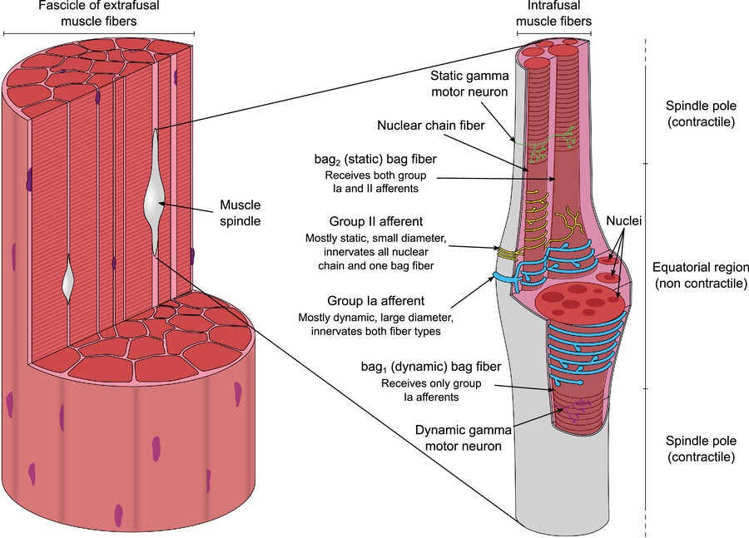
Figure 1.1: Morphology and internal structure of muscle spindles. Left: schematic of skeletal muscle fascicle showing the location of muscle spindles among extrafusal fibres. Right: detailed longitudinal view of a muscle spindle illustrating intrafusal fibre types (nuclear bag1, bag2, and chain fibres), associated sensory afferents (group Ia and II), γ-motor neuron innervation of the polar regions, and the encapsulated equatorial (non-contractile) zone. (Adapted from Santuz & Akay (2023)).

Intrafusal and Extrafusal Muscle Fibre Organization
Intrafusal fibres differ structurally from surrounding extrafusal fibres. Bag fibres show clustered nuclei in the equatorial region and contribute to dynamic and static stretch detection, while chain fibres show linear rows of nuclei and primarily sense static muscle length (Thornell et al., 2015; Feher, 2012; Maier & Mayr, 2007). By contrast, extrafusal fibres position nuclei peripherally beneath the sarcolemma (Amato & De Girolami, 2023). These structural distinctions motivate the hypothesis that nuclear envelope proteins exhibit fibre-type-specific spatial patterns.

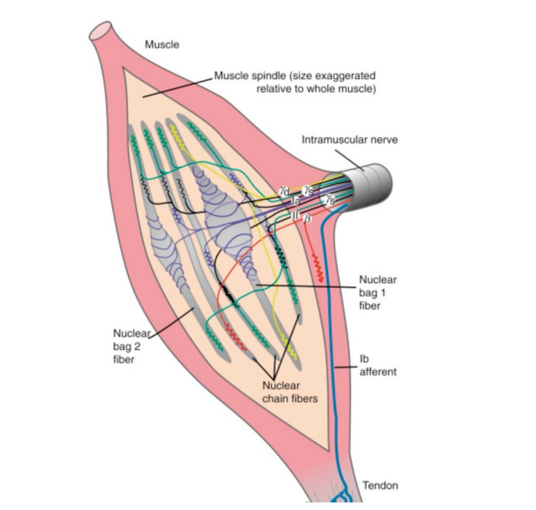
Figure 1.2: Structure of intrafusal muscle fibres. Representation of the inside of a muscle spindle depicting the structure of intrafusal muscle fibres, highlighting the appearance of nuclear bag and nuclear chain fibres. Bag 1 modulates dynamic sensitivity. Bag 2 (with chains) modulates static sensitivity. (Modified from Mentis, 2012).

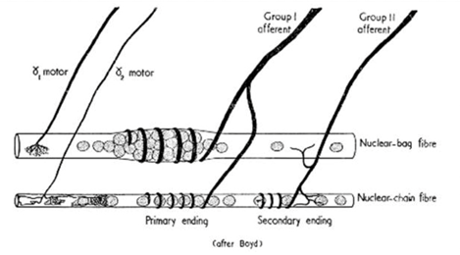
Figure 1.3: Nuclear bag versus nuclear chain fibres. Distinct nuclear organization in intrafusal fibres: clustered nuclei in nuclear bag fibres versus linear rows of nuclei in nuclear chain fibres. Group I afferent signal static and dynamic stretch. Group II signal only static stretch. (Adapted from Matthews, 1964).

Proteins of Interest
This study focuses on the spatial distribution of SUN2, Lamin-B1 and Nesprin-1, components of the LINC complex that links the nucleus to the cytoskeleton and is implicated in mechanotransduction (Starr & Fridolfsson, 2010; Chang et al., 2015).

Project Objectives
Overall Aim: To determine whether nuclear envelope protein localization can differentiate intrafusal from extrafusal regions in spindle cross-sections. The specific objectives are to:
- Characterize the spatial distribution of SUN2, Lamin-B1 and Nesprin-1 relative to nuclei within intrafusal and extrafusal fibres.
- Measure and compare the relative concentrations of these proteins between intrafusal and extrafusal fibres
- Apply a computational pipeline (CNN feature extraction, t-SNE, and clustering) to detect unbiased spatial patterns.
- Interpret these findings within the context of muscle spindle physiology, highlighting molecular features that may contribute to fibre function and reflex control.

Literature Review

Nuclear Envelope Proteins and Localization in Muscle Fibres
The nuclear envelope is central to nuclear organization and mechanical signal transduction, with SUN2, Lamin-B1, and Nesprin-1 forming part of the LINC complex that links nuclei to the cytoskeleton (Starr & Fridolfsson, 2010; Chang et al., 2015).

Imaging and Computational Approaches
Immunofluorescence remains the primary method for studying protein localization, combining brightfield structure, nuclear staining, and fluorescent protein markers. Traditional computational methods such as thresholding, watershed segmentation, and line-intensity profiling often struggle with overlapping nuclei and complex spatial patterns. Recent work by Shelley Buchan (2024) addressed this limitation by developing an automated segmentation pipeline for nuclear regions, enabling quantitative analysis of protein distributions. While her study provided a preliminary spatial analysis, this present study extends this by applying an unsupervised (due to limited data) clustering algorithm to classify segmented protein into distinct spatial patterns, allowing more systematic and interpretable insights into protein organization across cells.

Previous Work and Present Focus
Earlier studies on nuclear envelope protein localization largely relied on manual or classical image analysis (Buchan, 2024). This project advances the approach by implementing a data science pipeline that integrates CNN-based feature extraction (LeNet, ResNet-50), t-SNE dimensionality reduction and K-Means clustering. The framework aims to improve reproducibility and scalability while enabling the detection of novel spatial patterns in protein distribution that may reveal new aspects of spindle function.

Data

Image Data & Structure
The dataset comprises nine microscopy images, grouped into three aligned sets corresponding to specific nuclear envelope proteins: SUN2, Lamin-B1, and Nesprin-1. Each protein was imaged separately in the same cross-section of muscle tissue under uniform conditions, using three complementary microscopy techniques:
- DAPI-stained fluorescence (blue channel) to highlight nuclei and distinguish intrafusal from extrafusal regions in fibres.
- Alexa Fluor 594 immunofluorescence (red channel) to visualize spatial distribution of the targeted protein.
- Brightfield (TRANS) microscopy to provide tissue morphology, including spindle capsule and surrounding fibres.
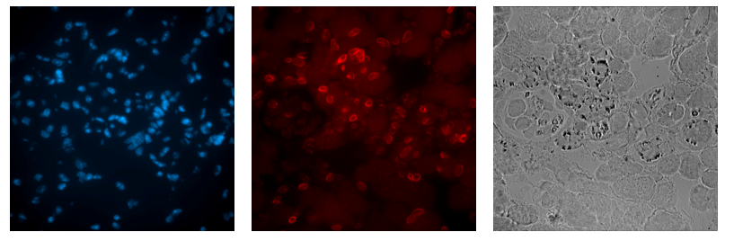
Figure 3.1: Fluorescence and brightfield images of SUN2 Proteins. DAPI (blue) and Alexa Fluor 594 (red), and corresponding brightfield image.

Image Pre-processing and Intensity Adjustment
To improve contrast, brightfield images were converted from RGB (3 channels) to grayscale (1 channel) and processed using histogram equalization, which redistributed pixel intensities to enhance contrast by stretching low-range intensities into uniform histogram bins.
For instance, the original TRANS image had a low dynamic range (mean = 0.47337, standard deviation = 0.09224) with uneven illumination and its histogram distribution showed a skewed distribution. After equalization, the histogram had a more balanced intensity profile (mean = 0.5, standard deviation = 0.2890) producing a visually enhanced image ready for segmentation.

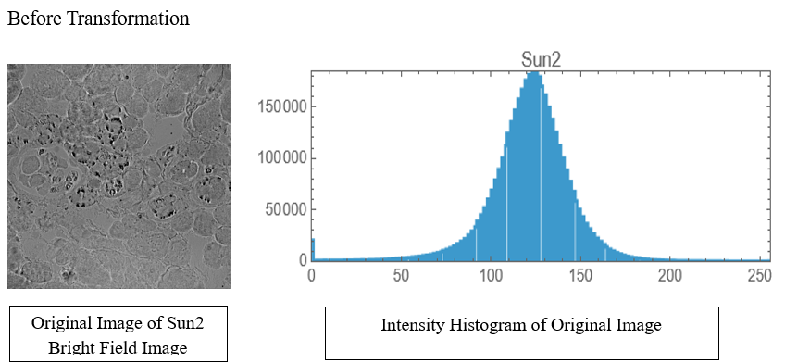
Figure 3.2: Original SUN2 image and intensity distribution before transformation.
Bright-field image of SUN2 (left) showing low dynamic range and uneven illumination. The corresponding histogram (right) displays a skewed intensity distribution (mean = 0.47337, SD = 0.09224), reflecting limited contrast across the image.
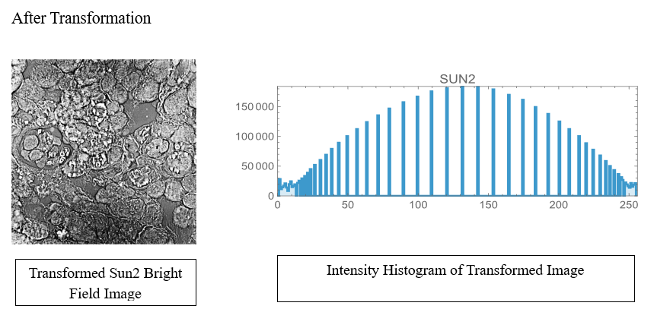
Figure 3.3: Transformed SUN2 image and intensity distribution after histogram equalization. Bright-field image of SUN2 (left) following histogram equalization. The corresponding histogram (right) shows a balanced intensity profile (mean = 0.5, SD = 0.2890), enhancing contrast and visual clarity, thereby improving suitability for downstream segmentation analysis

Methods

Main Pipeline
A computational pipeline (Figure 4.1) was implemented to classify protein spatial patterns. Segmented protein regions, derived from nuclear masks (Buchan, 2024), were used as inputs to this pipeline. These segments were processed with a pretrained Convolutional Neural Network (ResNet-50) model to extract high-dimensional feature vectors. These features were then reduced to two dimensions using t-SNE for visualization, and K-means clustering was used in an unsupervised manner to produce typically two or three distinct groups.
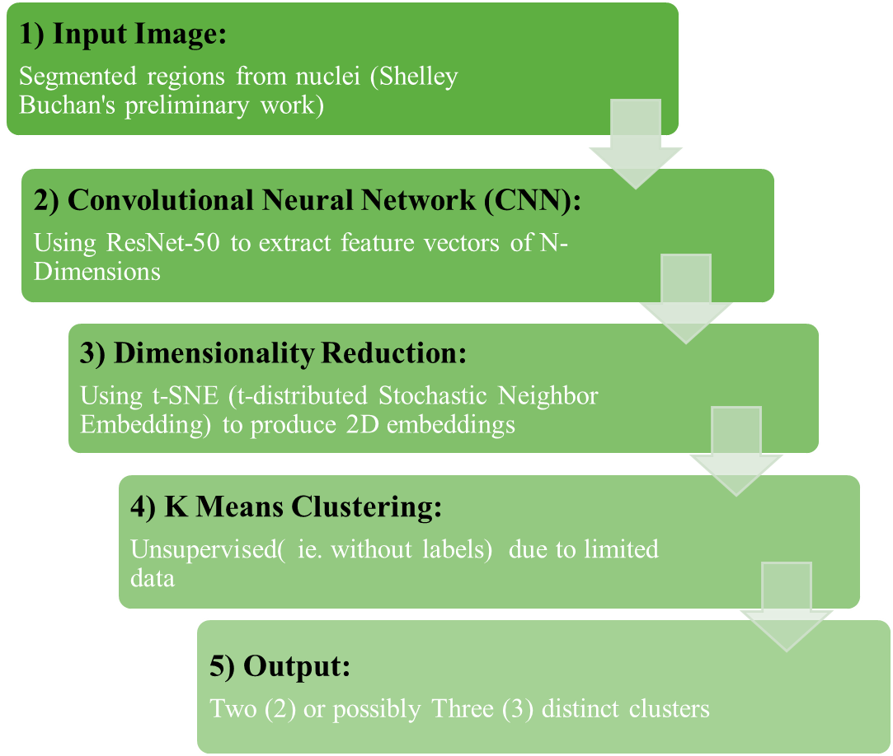
Figure 4.1: Computational Pipeline. Segmented protein regions are passed through ResNet-50 for feature extraction, reduced via t-SNE, and clustered with K-means.

Nuclei Segmentation (DAPI Channel)
Nuclei were segmented from DAPI-stained images using a marker-controlled watershed pipeline developed by Buchan (2024). The steps were:
- Gaussian smoothing to reduce noise and enhance nuclear structures.
- Entropy thresholding (Kapur's method) to separate nuclei from background.
- Local maxima detection to define seed markers for segmentation. These markers were applied to a gradient-filtered version of the image, which served as basis for watershed algorithm.
- Watershed segmentation on gradient image to separate overlapping nuclei.
- Labeling each nucleus with a unique identifier.
This method worked well due to DAPI channel's high contrast and discrete intensity peaks, allowing for clear separation and precise segmentation.
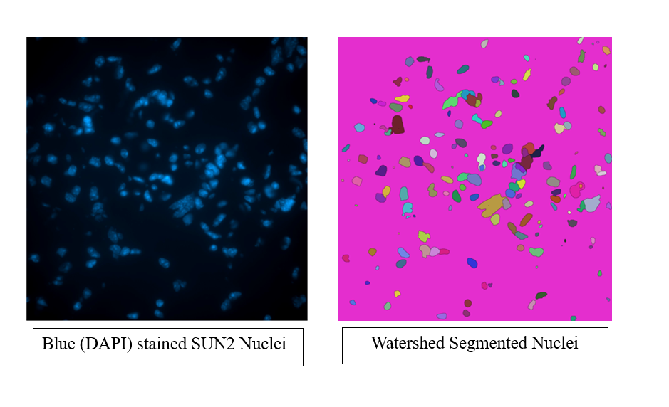
Figure 4.2: DAPI-stained SUN2 nuclei (left) and watershed segmentation output (right) with distinct labels.

Preliminary Analysis of Protein Spatial Distribution
An initial method, based on recent work by Buchan (2024) extracted horizontal and vertical intensity profiles of segmented SUN2 and DAPI channels. These profiles produced simple 1D representations, offering insight into localization patterns.
While useful for visual comparisons between nuclear types, the approach was not universally adaptable. It required manual interpretation and could not capture complex patterns in the form of explicit numerical feature vectors for automatic classification. These limitations motivated the transition to the automated CNN-based pipeline (Figure 4.1).

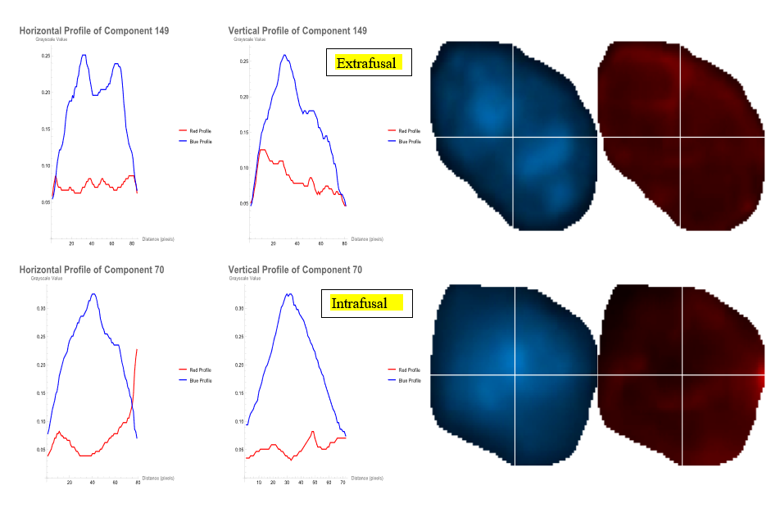
Figure 4.3: Example SUN2 localization profiles. Extrafusal nuclei (top) shows peripheral SUN2 enrichment, while intrafusal nuclei (bottom) display variable patterns.

Benchmarking Neural Networks with MNIST Dataset
A controlled pipeline validation step was performed using the MNIST (Modified National Institute of Standards and Technology) digit dataset prior to applying deep learning models to segmented protein images.
The MNIST is a widely used benchmark made up of grayscale images of handwritten digits (0–9) (LeCun et al., 1998). It was chosen for its simplicity, consistency, and well-defined visual structure, making it ideal for evaluating the ability of CNNs to extract and interpret image-based features. Additionally, the digit “0” was used to simulate biological conditions, as its circular morphology closely resembles that of stained nuclei.
To simulate feature extraction tasks, two digit-pairing tasks were tested:
- Digit 0 vs 1: visually distinct shapes.
- Digit 0 vs 6: structurally similar and are sometimes harder to differentiate
Each digit was processed through the same pipeline (Figure 4.1) and the procedure served as a baseline to verify model’s ability to capture subtle spatial differences prior to application on complex biological datasets.
Figure 4.4. Representative MNIST Digits (0, 1 and 6) used to benchmark feature extraction pipeline.

Deep Feature Extraction Using CNNs
To quantitatively compare protein expression patterns across segmented nuclei, pretrained CNNs were repurposed as feature extractors by removing their final classification layers. This stage forms a core component of the computational pipeline (see Figure 4.1).
CNNs are specialized deep learning architectures well-suited for image data and are capable of automatically detecting spatial patterns such as edges, textures, shapes and spatial transitions (LeCun et al., 1998; He et al., 2016). Their architecture typically comprises convolution layers, which apply small filters to identify features, as well as pooling layers, which reduce spatial dimensions while preserving important information.
In this project, two pretrained CNNs, LeNet and ResNet-50, were implemented using Wolfram Mathematica (Wolfram Neural Net Repository, n.d.) and repurposed as feature extractors rather than classifiers. This allows for an unbiased representation of image content, which is subsequently passed on to the other stages of the computational pipeline (see Figure 4.1).

LeNet
LeNet is a classical shallow CNN originally developed for handwritten digit recognition on the MNIST dataset (LeCun et al., 1998). In this project, LeNet was used as a baseline feature extractor for low-complexity images instead of a classifier by removing classification layers. It outputs a compact, dense one-dimensional(1D) feature vector representing each image digit.
MNIST data was first tested using this simplified architecture to validate the feature extraction process before applying deeper networks like ResNet-50, which comes pretrained on large-scale image datasets such as ImageNet. The LeNet model used was implemented from the Wolfram Neural Net Repository (Wolfram Neural Net Repository, n.d.).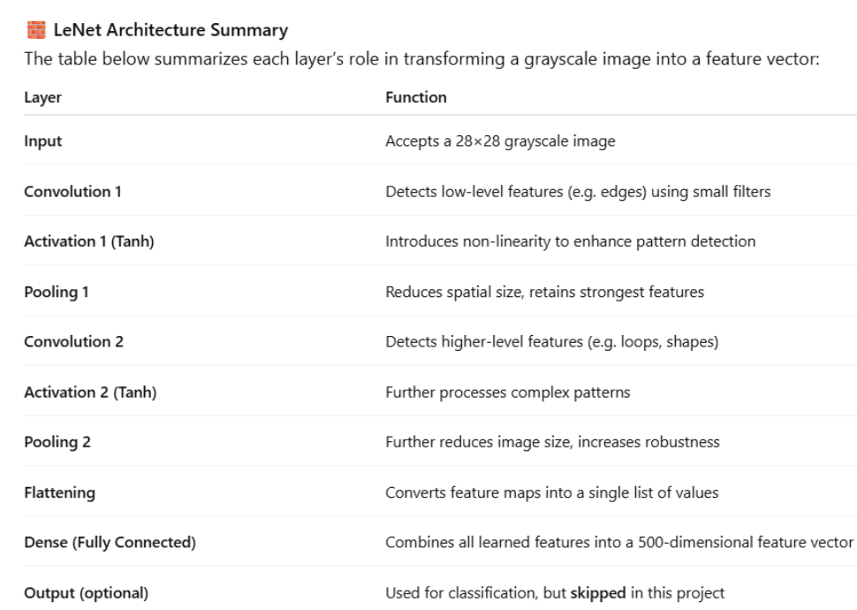
Figure 4.5: Layer-wise summary of the LeNet CNN used for feature extraction. (Adapted from LeCun et al., 1998 and the Wolfram Neural Net Repository implementation.)

ResNet-50 (Deep CNN)
To extract detailed visual features from the segmented biological images, a deep learning model called ResNet-50 was used. This model was chosen because it is well-suited for identifying complex patterns such as textures, shapes, and intensity differences which is particularly relevant for distinguishing between the fibre-specific types of nuclei in this study.
ResNet-50 contains 50 layers and uses a design called residual connection, which allows the model to pass information forward without modification, making it easier to train and more accurate for complex tasks (He et al., 2016). Instead of retraining the model from scratch, a pre-trained version, originally trained on millions of natural images from the ImageNet database, was used in this project. The final classification layer was removed, and the output from one of the last layers (global average pooling layer) was used to produce a 2048-dimensional feature vector for each image, which is simply a numerical summary of simple details and complex patterns.
These feature vectors were then passed into next steps outlined in pipeline (see Figure 4.1) to group similar images together and explore patterns in protein expression without needing manual labels or supervision due to limited data.
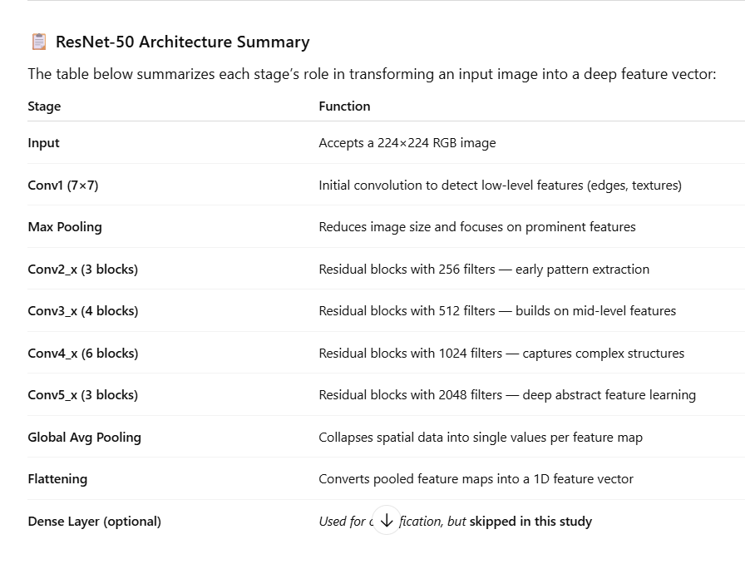
Figure 4.6. ResNet-50 Architecture summary, showing all layers before feature extraction to the penultimate layer (2048-dimensional vector) representing each image. (Adapted from He et al., 2016 and Wolfram Neural Net Repository).

Dimensionality Reduction Using t-SNE
To visualize and interpret the high-dimensional feature vectors produced by the CNNs, they need to be reduced into a more interpretable form and the method employed here is t-SNE.
t-distributed Stochastic Neighbour Embedding (t-SNE), introduced by van der Maaten and Hinton (2008), is a nonlinear algorithm that projects high-dimensional data into two or three dimensions for visualization. Unlike linear methods such as PCA, t-SNE preserves local neighbourhood structure, meaning that similar data points in the original space remain close together after reduction. This advantage makes it particularly valuable in deep learning applications, where it provides intuitive scatter plots that reveal potential clusters and relationships within biological image data (Cao et al., 2017; Wattenberg et al., 2016).
This allowed qualitative comparison of different image types, including biological and MNIST-derived samples.

Clustering via K-Means
Following feature extraction and dimensionality reduction with t-SNE, K-means clustering was applied as an unsupervised method to group unlabeled data based on feature similarity. The purpose of using K-means in this study was to determine whether unsupervised learning alone could meaningfully group protein distribution patterns in the absence of explicit labels.
K-means, first introduced by Lloyd (1982), partitions data into k clusters by iteratively assigning each data point to the nearest centroid and updating cluster centers until convergence. Despite its simplicity, the algorithm has proven highly effective for pattern discovery in high-dimensional datasets. In microscopy applications, K-means has been widely used to uncover biologically meaningful structures, with colour-coded clusters offering interpretable representations of differences in protein localization (Jain, 2010; Xie et al., 2016).
To support interpretation in this study, clusters were visualized using perceptually uniform colour palettes (ColorData [97], from Wolfram), ensuring clear separation and consistent mapping across figures (Brewer, 1994).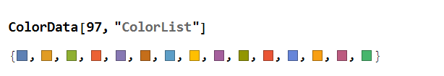
Figure 4.7. Example colour palette (ColorData [97], Wolfram Mathematica) used for visualizing clusters.

Summary of Methodology
This study integrated classical image processing with modern deep learning to analyze protein spatial distributions at the single-nucleus level. The pipeline was validated using the MNIST digit dataset as a benchmark, before being applied to segmented protein images, providing a robust, reproducible framework for detecting and comparing protein expression patterns without labels.

Results

Validation with MNIST Dataset
The MNIST dataset was used to benchmark the pipeline prior to application on segmented protein images. Digit “0” was chosen as a proxy for nuclear morphology, while digits “1” and “6” tested the network’s ability to separate distinct (0 vs 1) and visually similar (0 vs 6) classes.

Feature Extraction, Dimensionality Reduction & Clustering
Feature vectors from selected MNIST digit pairs were extracted using LeNet and ResNet-50, then reduced to two dimensions with t-SNE for visualization. K-means clustering was applied using two distance metrics: Mathematica’s default (groups based on angular similarity) and Euclidean (groups based on straight-line proximity). This comparison tested whether cluster separation is more sensitive to the direction of the features or their absolute positions. For each cluster, “Length” indicates the total number of images per cluster, while “Dimensions” confirms that the feature vectors are 1D, validating that clustering operated on individual image embeddings rather than multidimensional arrays.

Digits 0 vs 1

Feature extraction and clustering of digits “0” and “1” showed that both LeNet and ResNet-50 separated visually distinct classes effectively when paired with Euclidean distance.
For LeNet, two clusters were observed with minimal overlap (Figure 5.1). Accuracy exceeded 99% for both digits (Table 5.1), with digit “1” classified almost perfectly. A small number of “1” samples appeared within the “0” cluster, likely due to handwriting variants (i.e. serifed or curved “1” resembling “0”) and projection effects in t-SNE. This indicates that even a shallow architecture can discriminate between simple shapes when combined with an appropriate distance metric.
For ResNet-50, clusters were even more compact and sharply defined (Figure 5.2). Accuracy again exceeded 98% (Table 5.2), with digit “1” forming a particularly tight sub-group. Interestingly, ResNet-50 also revealed a small secondary cluster of “1”, which may reflect consistent local feature differences between handwriting styles of the digit (e.g., “I”-like versus “1” with base). Compared to LeNet, the deeper network improved boundary resolution, provided denser clusters and finer subdivision of intra-class variation, confirming its advantage in encoding subtle features.
In summary, both models achieved high performance on this digit pair (>98% accuracy). However, ResNet-50 yielded greater intra-cluster compactness and sharper separation, confirming the value of deeper architectures for robust feature encoding.

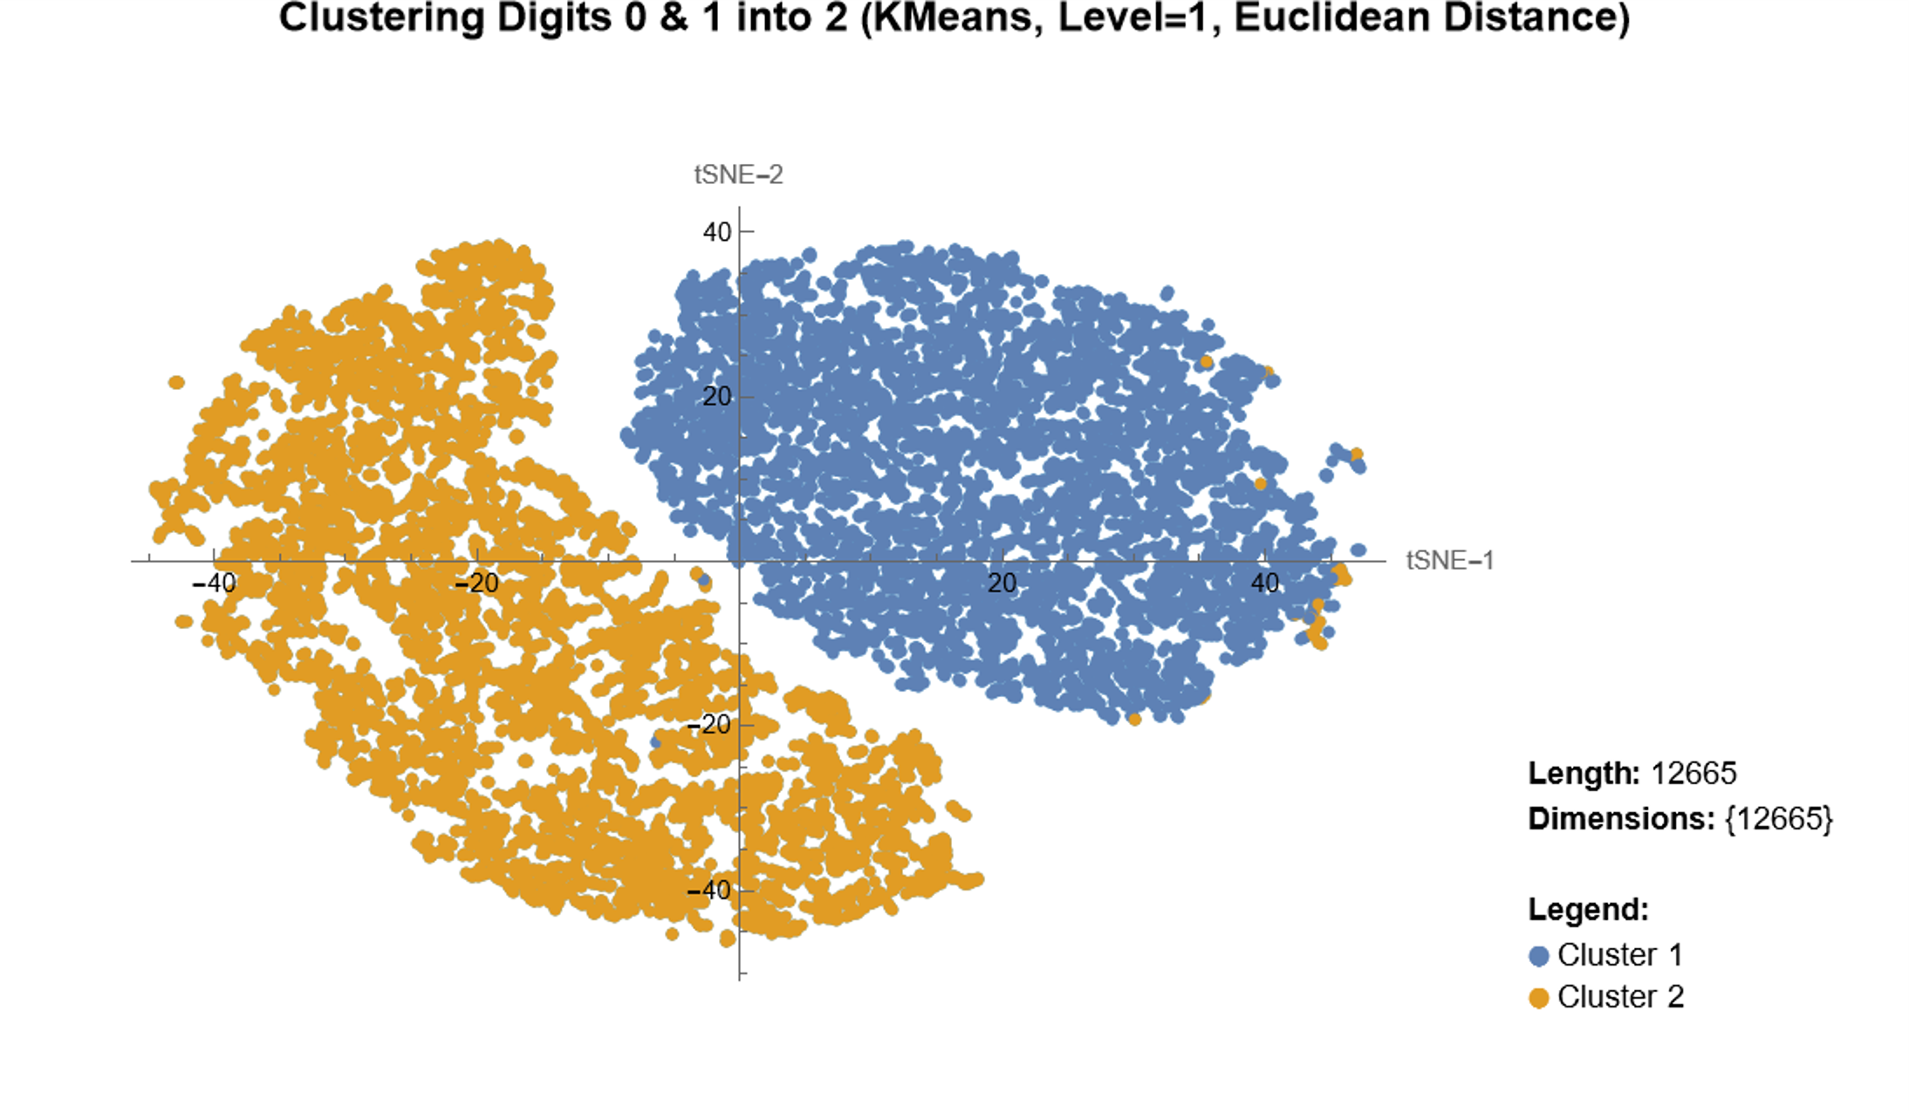
Figure 5.1: t-SNE visualization of LeNet-extracted features for MNIST digits “0” (blue) and “1” (yellow), clustered using K-means with Euclidean distance. Two clearly separated clusters are observed with minimal overlap; a few digit “1” samples appear within the digit “0” cluster.

Table 5.1: Confusion matrix for LeNet features (digits “0” vs “1”), clustered using K-means with Euclidean distance.
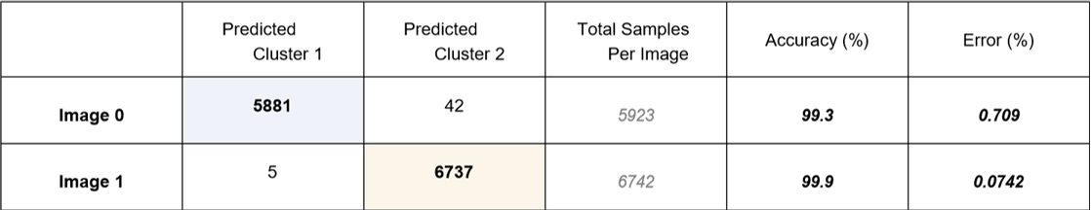

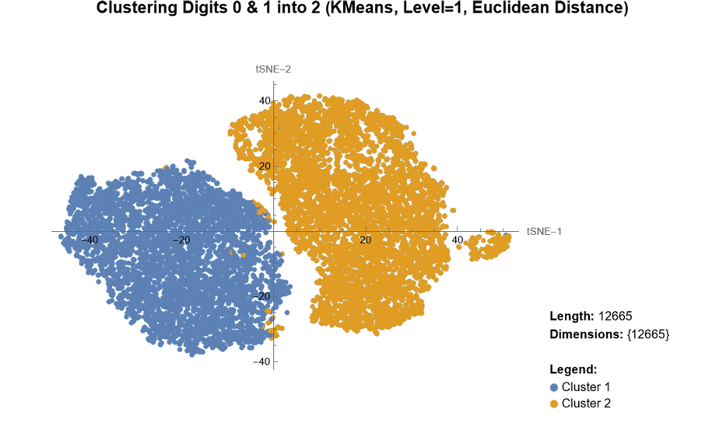
Figure 5.2: t-SNE visualization of ResNet-50-extracted features for MNIST digits “0” (blue) and “1” (yellow), clustered using K-means with Euclidean distance. Clusters are compact, with a small secondary subgroup observed for digit “1”.

Table 5.2: Confusion matrix for ResNet-50 features (digits “0” vs “1”), clustered using K-means with Euclidean distance.
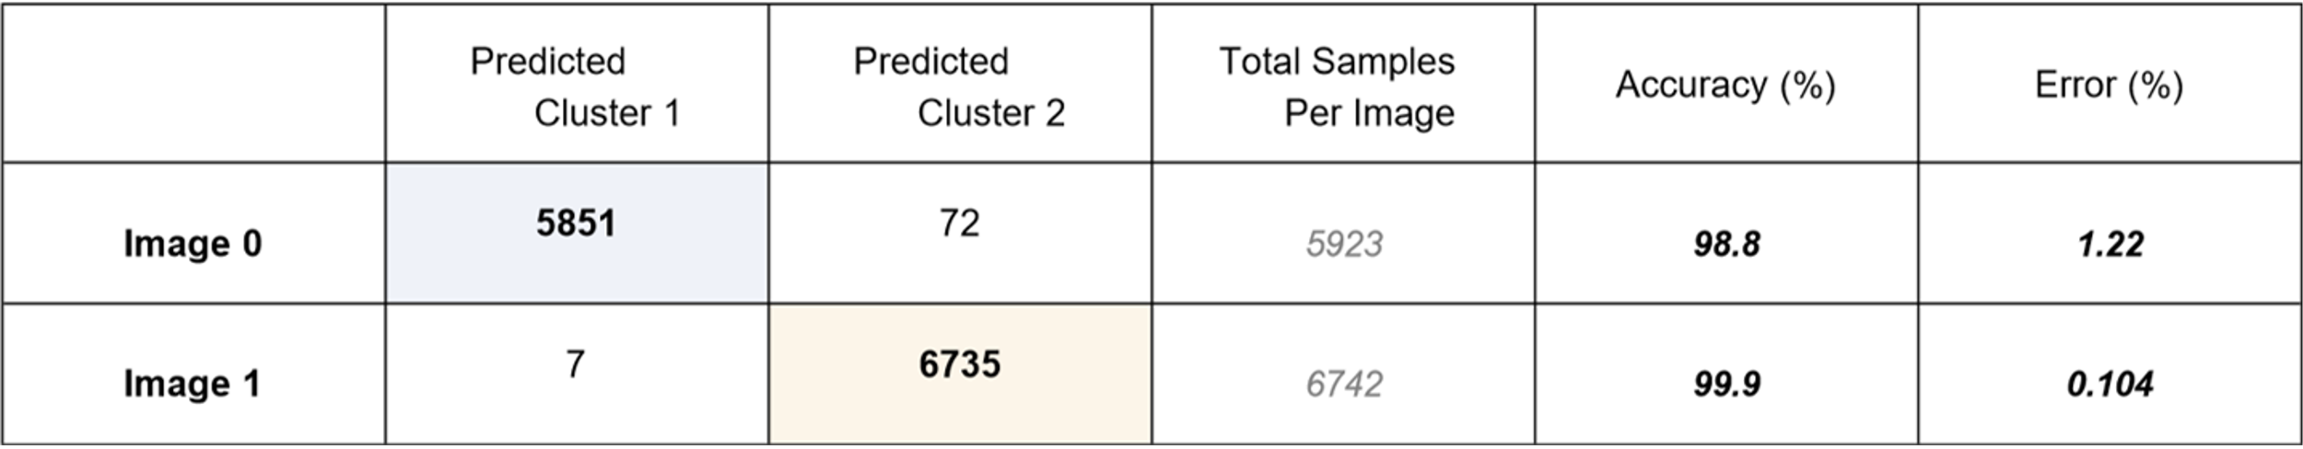

Digits 0 vs 6
Feature extraction and clustering of digits “0” and “6” revealed greater difficulty compared to the “0 vs 1” task, due to their shared rounded morphology.
For LeNet, the clusters were moderately separated (Figure 5.3). Digit “6” (yellow) formed a relatively compact group, while digit “0” (blue) appeared more diffuse and overlapped substantially along the central boundary. This resulted in frequent misclassifications, particularly for digit “0”, which showed an error rate of 8.36% (Table 5.3). The overlap zone often reflected similarities in looped “6” and elongated “0” shapes. The diffuse spread of digit “0” indicates that LeNet’s shallow architecture lacked the capacity to encode subtle intra-class variations, limiting its performance on visually similar digits.
ResNet-50 produced an improved but imperfect separation (Figure 5.4). The two clusters were largely separable, with digit “6” (blue) forming a compact, well-defined group. Digit “0” (yellow), however, appeared elongated along one axis, reflecting sub-variations within the digit class (e.g., narrow versus wide “0”). This elongation produced some boundary spillover and accounted for the higher error rate of 9.86% for digit “0” (Table 5.4). Nevertheless, the directional alignment of clusters and the compactness of digit “6” highlight ResNet-50’s stronger ability to capture fine-grained features compared to LeNet.
In summary, both models exhibited reduced accuracy relative to the simpler “0 vs 1” task, highlighting the challenge of distinguishing digits with similar topologies. LeNet produced broader, less compact clusters with greater overlap, while ResNet-50 achieved tighter alignment and reduced misclassification, especially for digit “6”. These findings underscore the advantage of deeper architecture in resolving subtle morphological similarities.

See Supplementary Material for equivalent comparisons of LeNet and ResNet-50 on digit pairs “0 vs 1” and “0 vs 6” using Mathematica’s default distance metric.

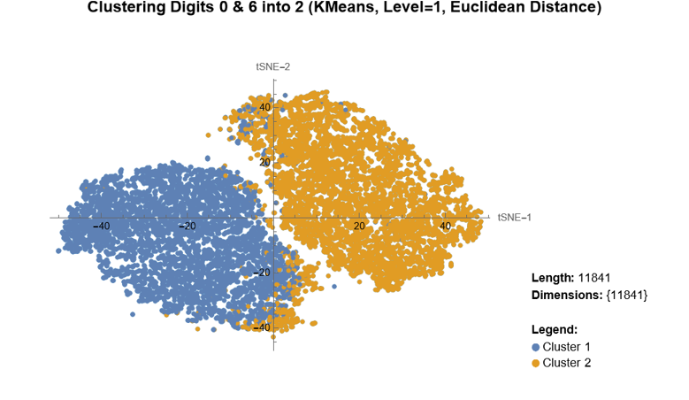
Figure 5.3: t-SNE visualization of LeNet-extracted features for MNIST digits “0” (blue) and “6” (yellow), clustered using K-means with Euclidean distance. Digit “6” forms a compact group, while digit “0” is more diffuse, with overlap along the central boundary.

Table 5.3: Confusion matrix for LeNet features (digits “0” vs “6”), clustered using K-means with Euclidean distance.
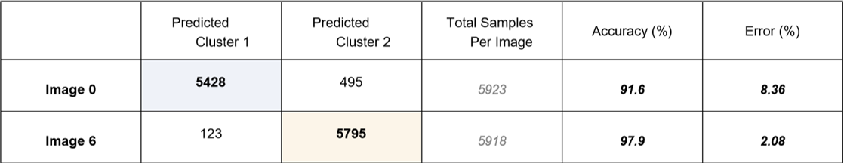
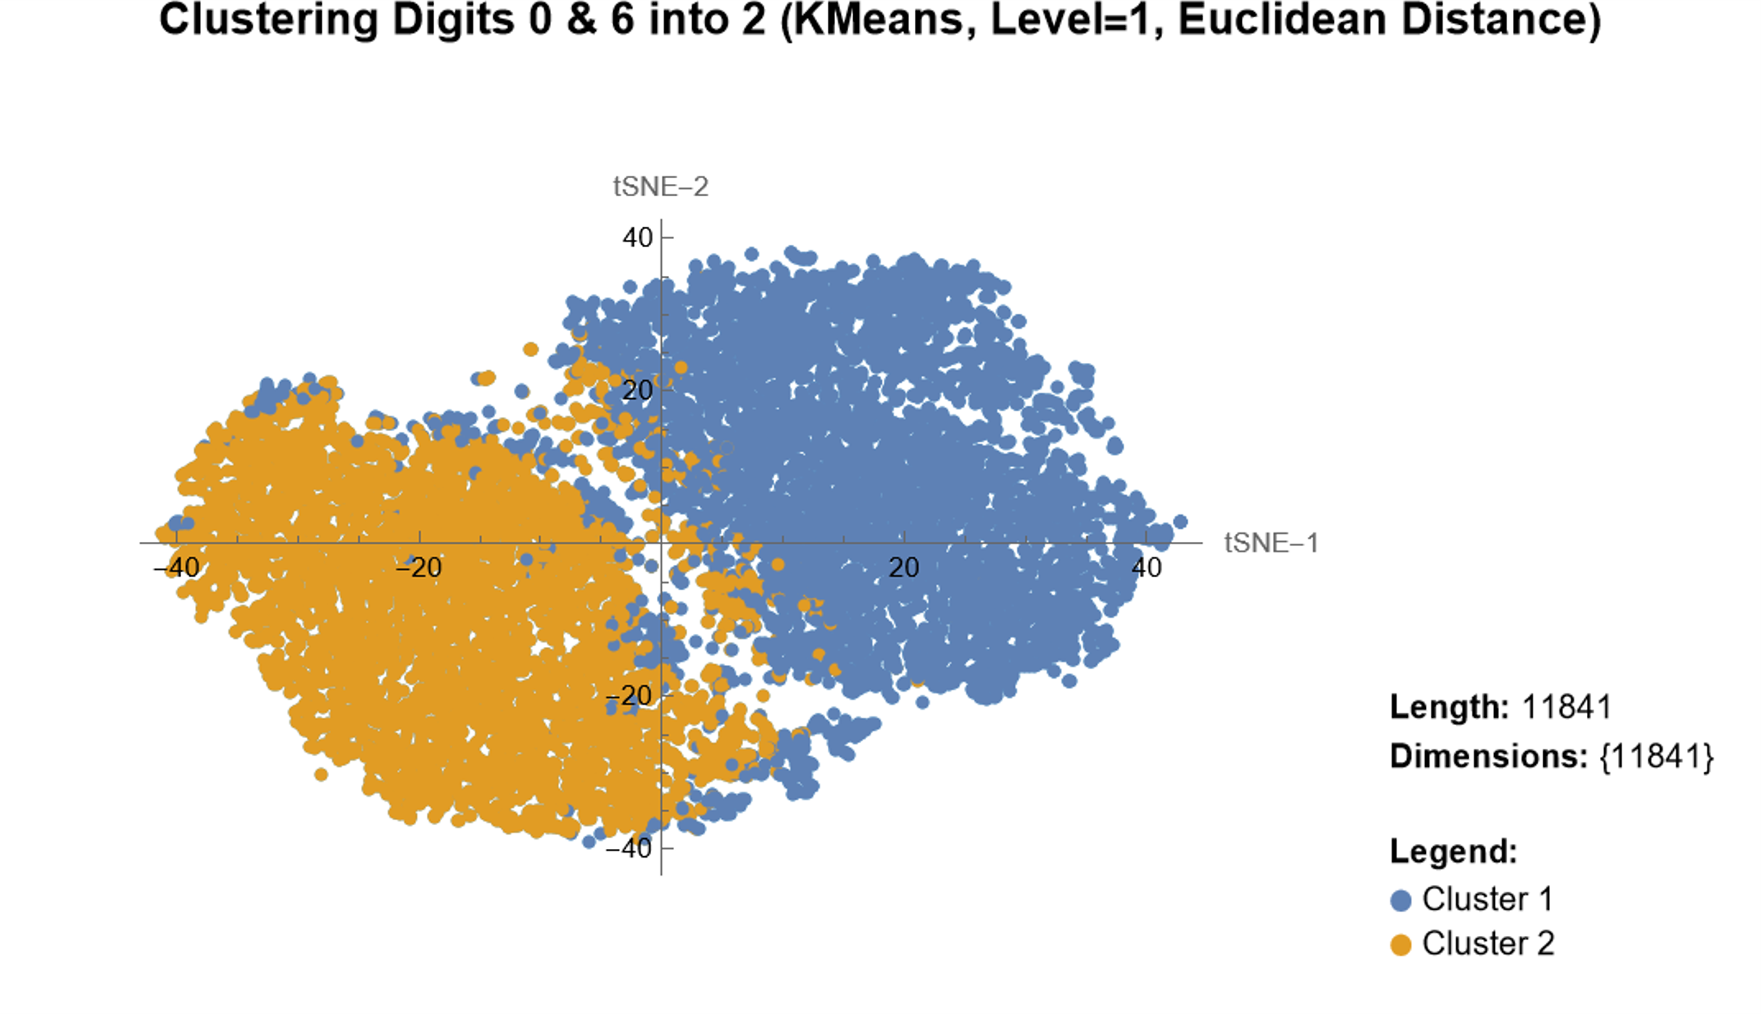
Figure 5.4: t-SNE visualization of ResNet-50-extracted features for MNIST digits “0” (yellow) and “6” (blue), clustered using K-means with Euclidean distance. Digit “6” forms a compact group, while digit “0” is elongated with partial boundary overlap.

Table 5.4: Confusion matrix for ResNet-50 features (digits “0” vs “6”), clustered using K-means with Euclidean distance.
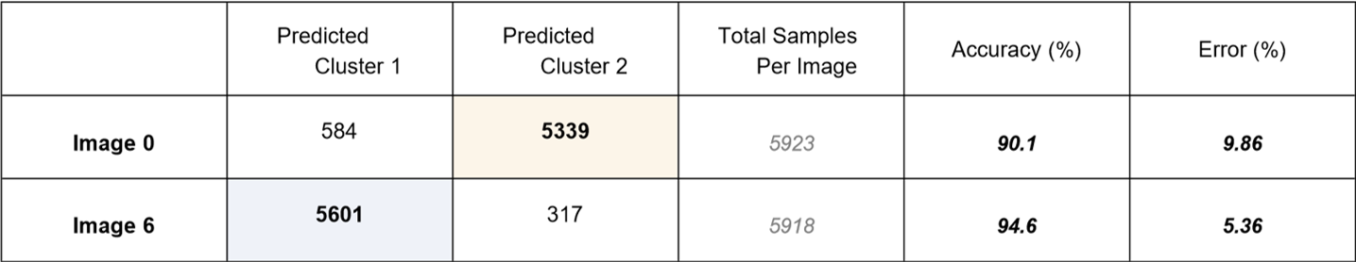

Protein Feature Clustering Using ResNet-50
Considering that ResNet-50 with Euclidean produced visually distinct clusters with a higher accuracy, it was implemented on the actual biological microscopic images.

Segmented SUN2 Proteins Only
Segmented SUN2 protein images (red channel) were extracted using nuclei-derived masks, yielding cropped regions for each cell (Figure 5.5). These protein-only segments were processed with ResNet-50 to generate high-dimensional features, which were then clustered using the pipeline in Figure 4.1.

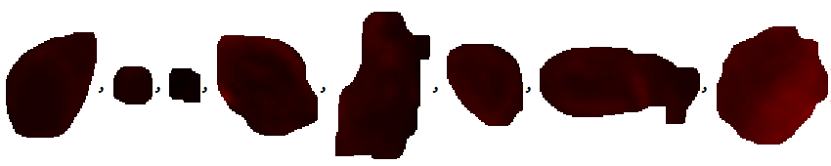
Figure 5.5: Examples of segmented SUN2 protein regions extracted from nuclei masks. Each cropped image corresponds to an individual protein-stained region, used as input to ResNet-50.

Clustering into 2 groups, placed most proteins into a broad, diffuse cluster, while a smaller compact cluster remained distinct (Figure 5.6, top). This provided only limited structural resolution. In the 3-cluster model, the compact subgroup was preserved, while the diffuse cluster subdivided into two subsets (Figure 5.6, bottom), revealing finer heterogeneity in protein organization.
In tissue overlays, the 2-cluster model partially distinguished the capsule-associated proteins from surrounding signals, whereas the 3-cluster model revealed better spatial differentiation: intrafusal proteins grouped into a consistent cluster, the capsule boundary separated distinctly, and extrafusal fibres formed a more heterogeneous region (Figure 5.7).
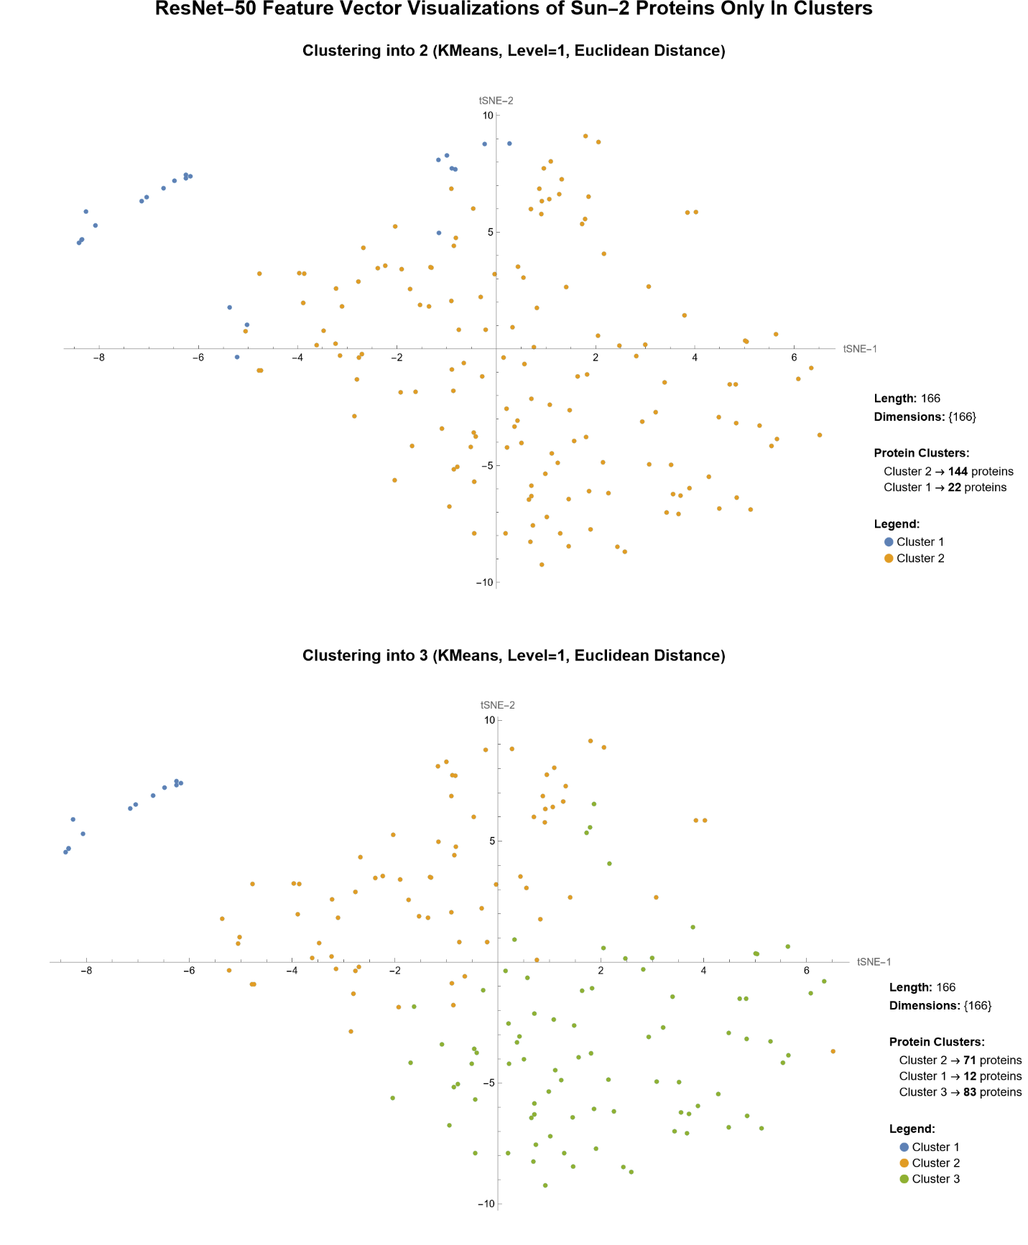
Figure 5.6: t-SNE visualizations of ResNet-50-extracted SUN2 protein feature vectors only, clustered with K-means using Euclidean distance. Top: 2-cluster model showing one diffuse and one compact group. Bottom: 3-cluster model with the diffuse group subdivided into two subsets.

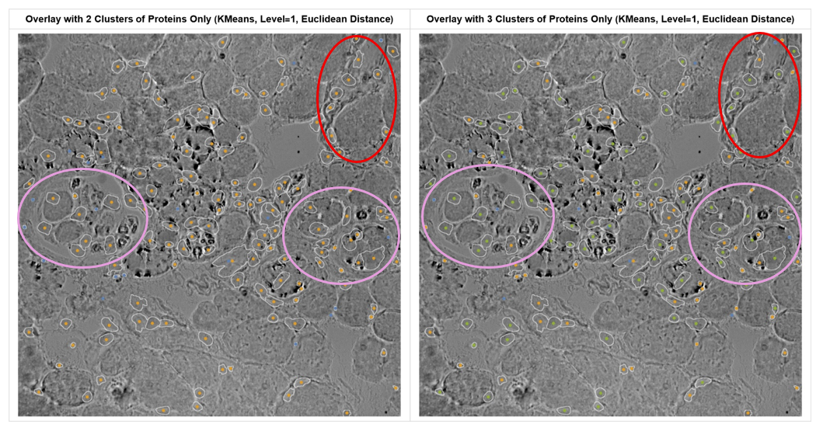
Figure 5.7: K-means clustering of SUN2 protein-only images overlaid on muscle tissue. In the 2-cluster view (left), protein signals within the spindle capsule (purple outlines) are split: the capsule edge forms a distinct cluster (blue), while proteins inside the intrafusal fibres group differently. In the 3-cluster view (right), a new green cluster clearly groups most intrafusal regions, distinguishing them from both the capsule boundary and surrounding extrafusal fibres (red).

Combining Segmented SUN2 Nuclei & Proteins
To reduce information loss and capture a fuller representation of cellular organization, protein features were combined with corresponding nuclear features to form a joint feature vector. Adding nuclei was expected to refine cluster boundaries and improve separation of tissue compartments.

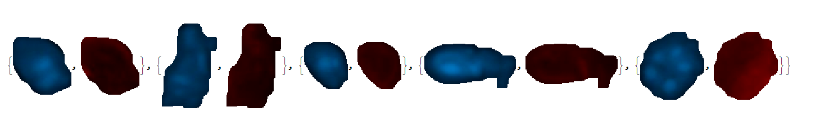

Figure 5.8: Examples of segmented SUN2 proteins (red) paired with corresponding nuclei (blue) extracted from immunofluorescent images. Each pair was used as joint input for ResNet-50 feature extraction.

Clustering of the combined features showed that the 2-cluster model grouped most proteins-nuclei pairs into a broad cluster, with a smaller compact subgroup separated but lacking clear biological boundaries (Figure 5.9, top). In the 3-cluster model, this compact group was retained while the diffuse cluster subdivided into two balanced subsets (Figure 5.9, bottom) indicating greater structural resolution from nuclear context. When overlaid on tissue images (Figure 5.10), the 2-cluster model only separated capsule regions from intrafusal areas, whereas the 3-cluster model revealed clearer discrimination between intrafusal proteins, the capsule boundary, and extrafusal fibres. This confirms that including nuclei enhances clustering granularity and yields more biologically interpretable patterns than protein features alone.

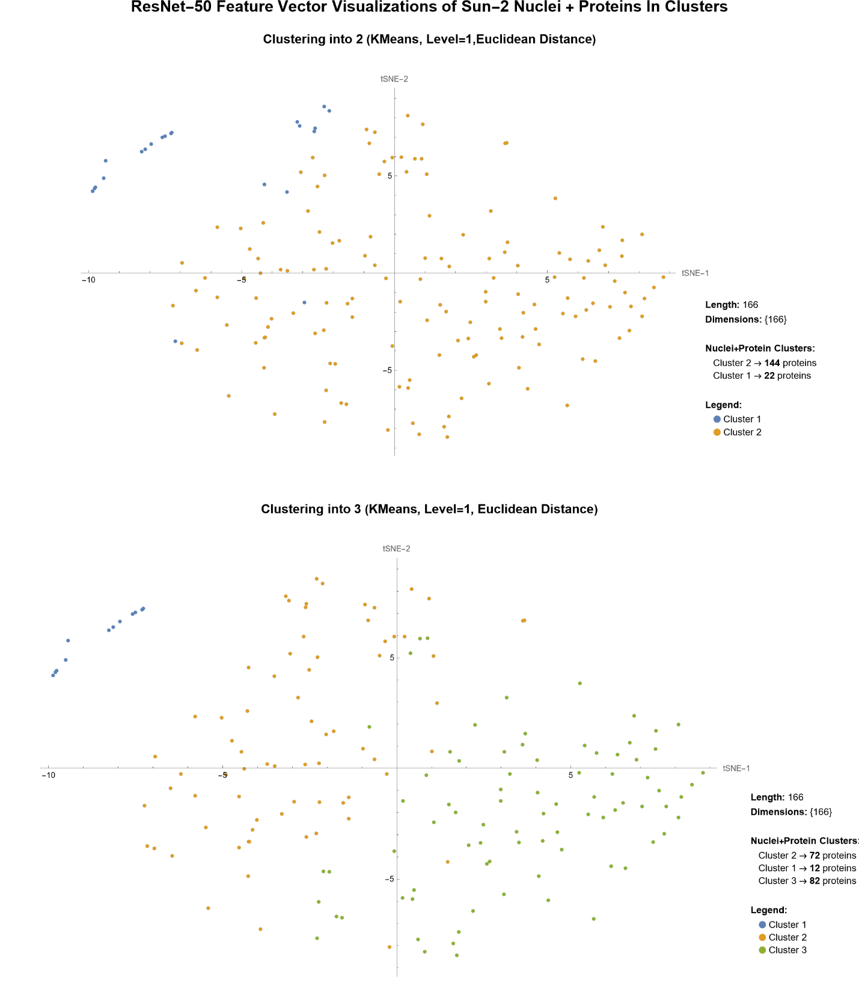
Figure 5.9: t-SNE visualizations of combined SUN2 nuclei and protein feature vectors extracted using ResNet-50 clustered with K-means using Euclidean distance. Top: 2-cluster model shows one broad and one compact group. Bottom: 3-cluster model showing subdivision of the broad group into two balanced clusters while smaller subgroup remains stable.

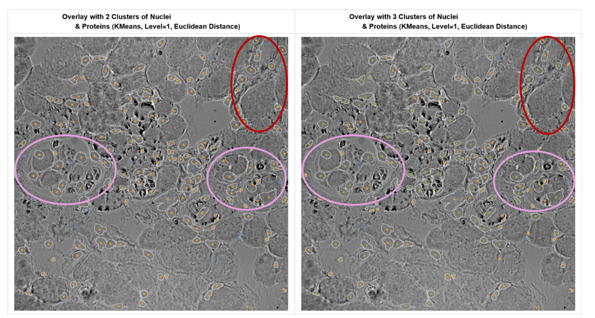

Figure 5.10: Overlay of K-means clustering results from combined SUN2 nuclei and protein features on brightfield images. Left: 2-cluster model show intrafusal regions (purple) appear fragmented—cluster edges outline the capsule, while the inner fibre shows groups differently. Right: 3-cluster model shows a distinct green cluster now clearly groups intrafusal regions more consistently, and separates capsule boundary, and extrafusal regions (red).

Troubleshooting Input Dimensions Images for ResNet-50

Combining Resized Segmented SUN2 Nuclei & Proteins
ResNet-50 requires inputs of 224 × 224 pixels in RGB format, whereas the segmented SUN2 protein–nuclei pairs were of varying dimensions in RGBA. To ensure compatibility, all pairs were resized and converted (Figure 5.11). Although resizing may reduce fine details, it enabled consistent feature extraction and improved clustering outcomes.

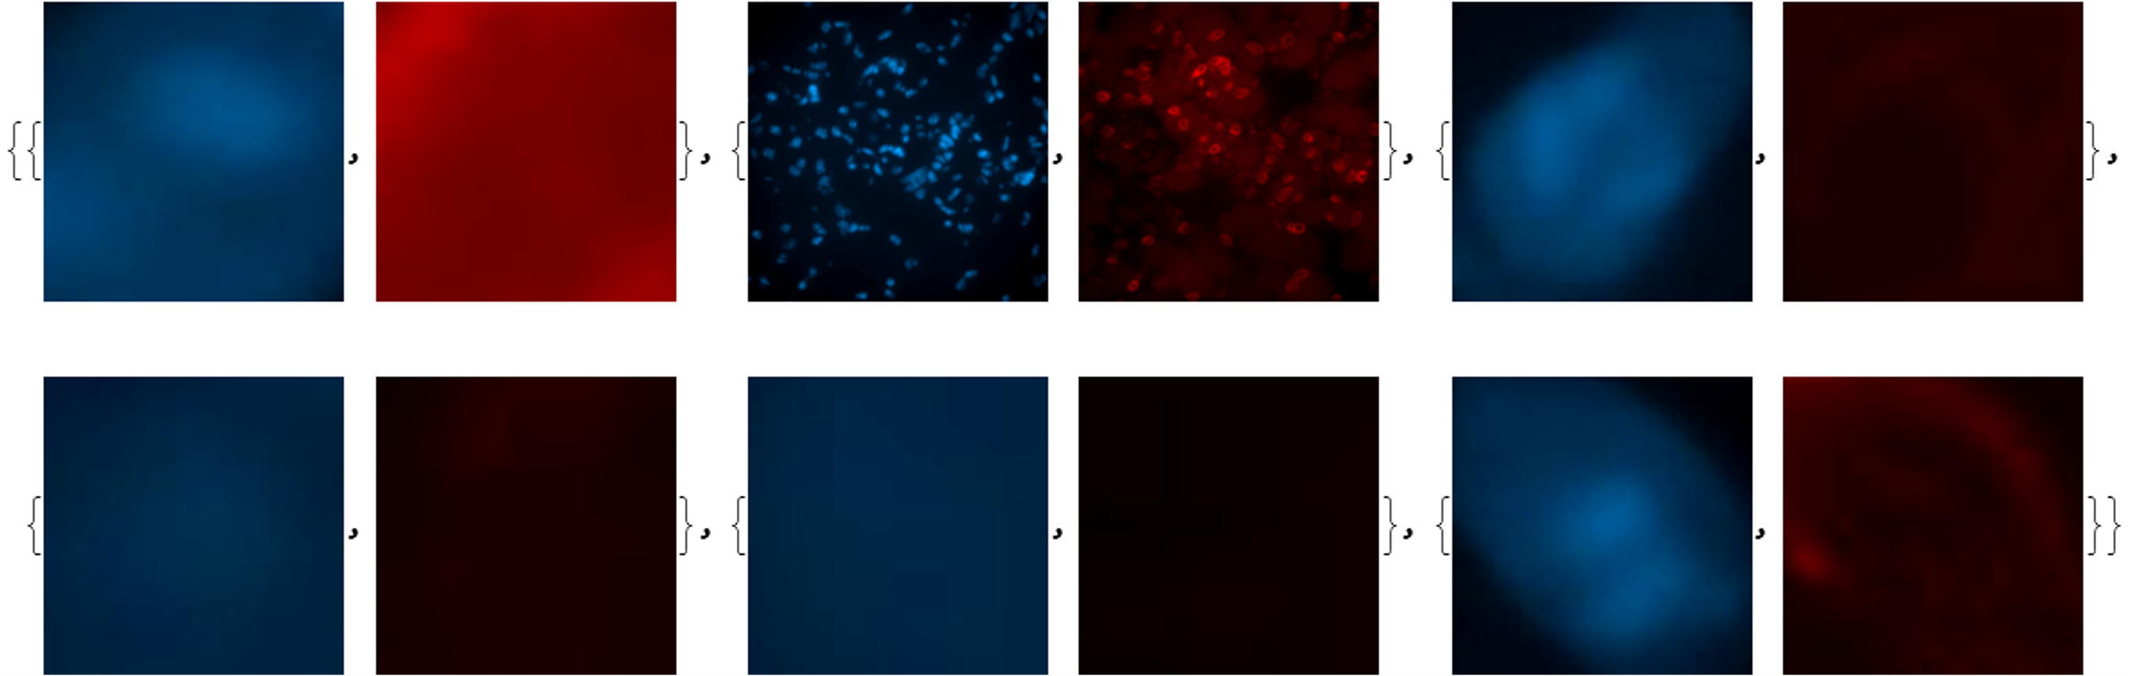

Figure 5.11: Examples of resized SUN2 protein-nuclei paired images (224 × 224, RGB). Each pair combines segmented nuclei (blue) and proteins (red) as inputs standardized for ResNet-50 feature extraction.

In the 2-cluster model, protein–nuclei pairs grouped broadly with only partial separation between capsule and intrafusal regions (Figure 5.12, top). However, the 3-cluster model (Figure 5.12, bottom) preserved the compact subgroup and further subdivided the diffuse cluster into two, revealing finer heterogeneity.
Tissue overlays (Figure 5.13) confirmed this: the 2-cluster model showed mixed intrafusal and capsule boundaries, while the 3-cluster model achieved clearer separation of intrafusal proteins (purple), capsule edges (yellow), and extrafusal fibres (red). Thus, despite potential information loss, resizing combined with nuclear context, enhanced ResNet-50’s ability to capture subtle structural distinctions.

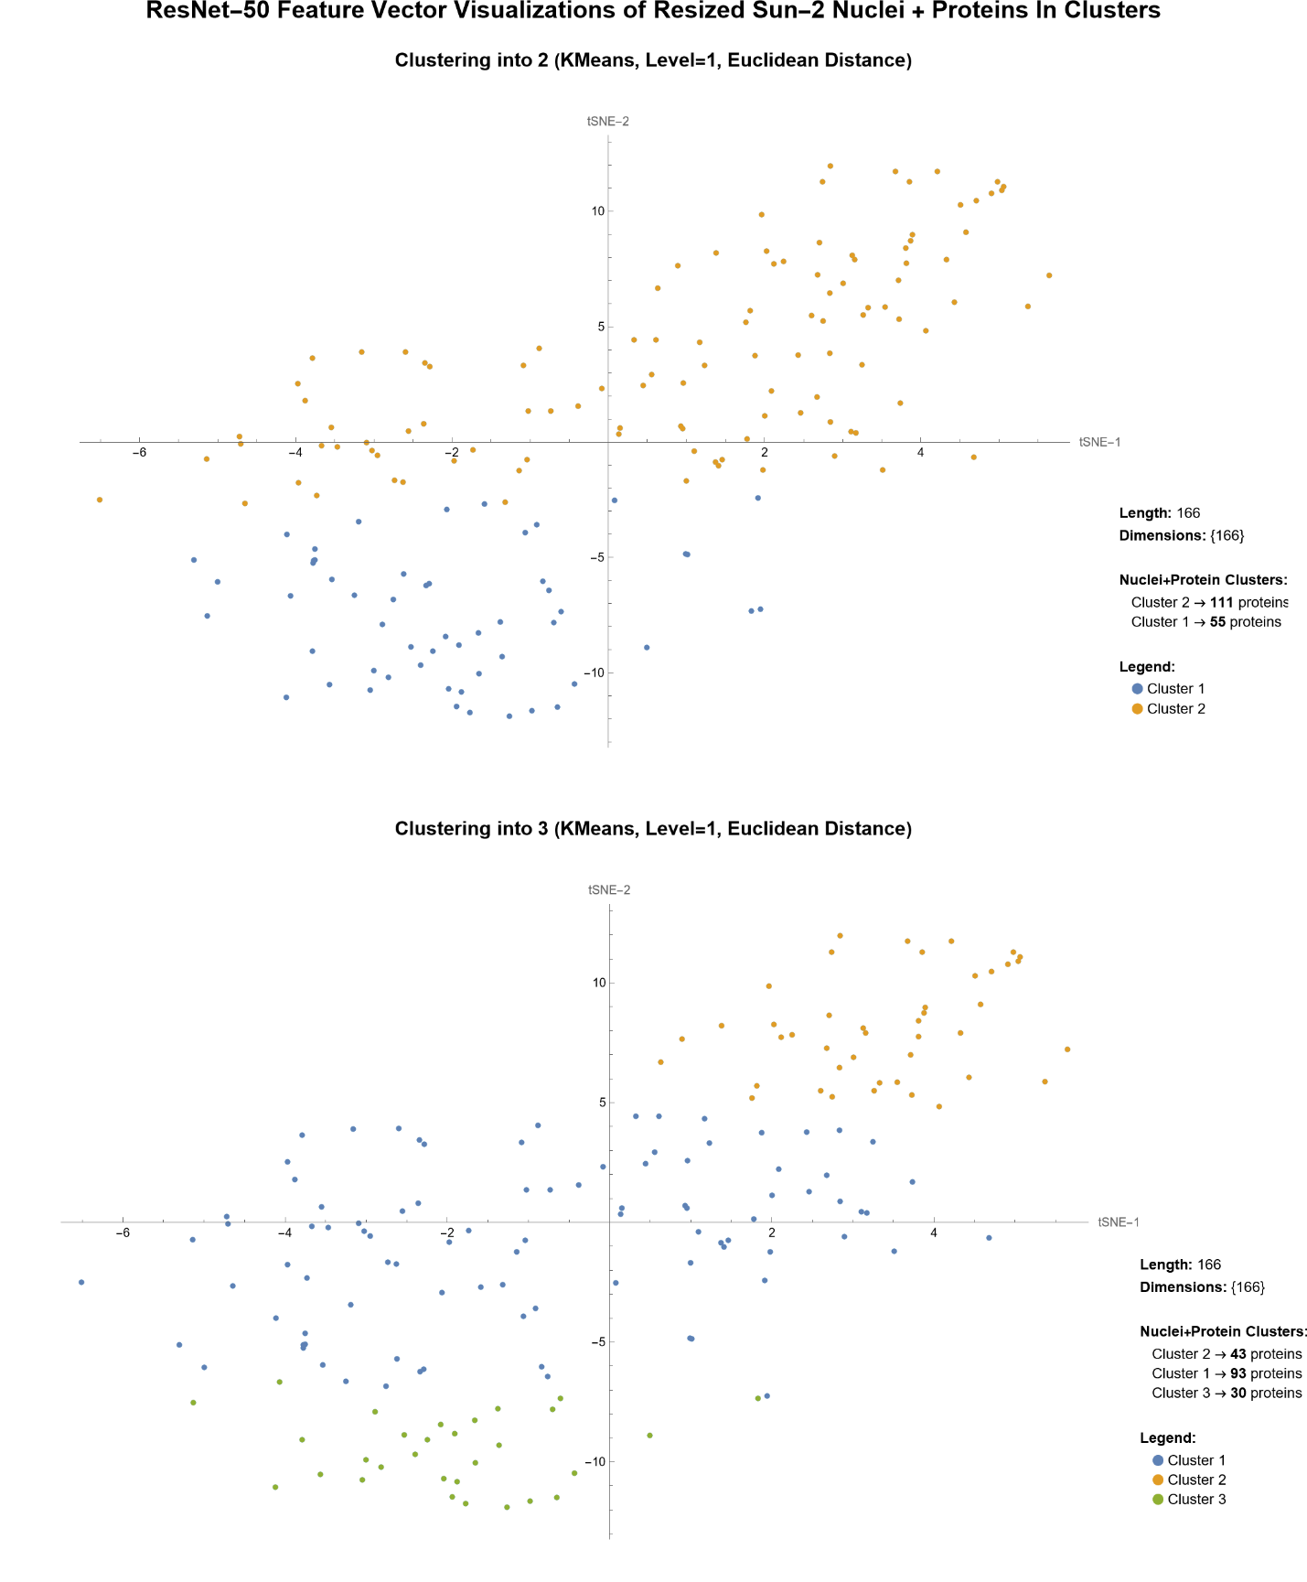
Figure 5.12: t-SNE visualizations of ResNet-50 features extracted from resized (dimensions: 224×224, color channel: RGB) SUN2 protein-nuclei paired images, clustered using K-means with Euclidean Distance. Top: 2-cluster result shows a broad separation between major protein groups, while the 3-cluster solution reveals a more refined subdivision.

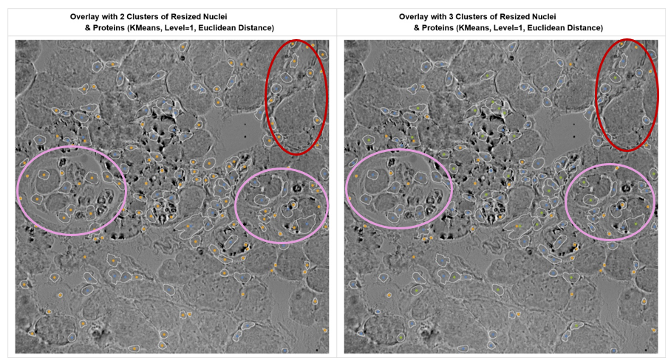

Figure 5.13. Overlay of clustering results using resized SUN2 protein-nuclei inputs.
Left: 2-cluster model shows mixed intrafusal regions (purple) with spindle capsule boundaries and inner fibres grouped inconsistently. Right: 3-cluster view reveals a more consistent grouping of intrafusal areas and improved separation of extrafusal fibres (red).

The same clustering pipeline was also replicated on Lamin-B1 and Nesprin-1 datasets. Full visualizations are included in the Supplementary Material, with selected overlays shown in Appendix A and B.

Discussion
The central aim of this study was to evaluate whether nuclear envelope protein distribution can differentiate intrafusal from extrafusal fibres within muscle spindle cross-sections. Using the computational pipeline (Figure 4.1), deep features extracted with ResNet-50 were reduced via t-SNE and clustered with K-means. The resulting overlays consistently revealed three structural compartments: a compact intrafusal cluster, a distinct capsule boundary, and a diffuse extrafusal region. This demonstrates that protein spatial distribution alone can uncover biologically meaningful architecture without labelled datasets.
As a benchmark to validate the pipeline, the MNIST digit dataset was first analyzed. Both LeNet and ResNet-50 successfully separated digit pairs, but ResNet-50 produced tighter, more compact clusters, particularly in the challenging “0 vs 6” comparison (Figures 5.1–5.4). These results confirmed that deeper architectures capture subtle differences more effectively than shallow networks, and therefore ResNet-50 was selected for protein feature extraction. Full comparisons using Mathematica’s default distance metric are provided in the Supplementary Material.
In the SUN2 protein-only analysis (Figures 5.5–5.7), the 2-cluster model provided only coarse separation, while the 3-cluster solution revealed clearer subdivision into intrafusal fibres, capsule, and extrafusal compartments. The intrafusal cluster appeared compact and stable, reflecting their morphological and molecular uniformity (Macefield & Knellwolf, 2018; Banks, 2006). In contrast, extrafusal fibres displayed diffuse clustering, consistent with their fibre-type diversity and peripheral nuclear positioning (Maier & Mayr, 2007).
When nuclear features were combined with proteins (Figures 5.8–5.10), cluster resolution improved further. The 3-cluster model provided a more distinct separation between intrafusal fibres, capsule boundaries, and extrafusal fibres, with the capsule frequently forming its own cluster. This supports its role as a biochemically distinct transitional zone, possibly involved in compartmental signaling or mechanical stress transmission (Rahman et al., 2018).
Finally, resizing inputs to the 224×224 RGB format required by ResNet-50 (Figures 5.10–5.12) stabilized clustering and improved reproducibility. Although resizing risks some detail loss, it produced consistent 3-cluster overlays in which intrafusal regions remained compact, capsule boundaries were delineated, and extrafusal fibres were more clearly separated. This highlights the trade-off between data fidelity and model requirements.
Together, these results show that deep feature extraction with ResNet-50, combined with unsupervised clustering, consistently identifies intrafusal fibres, capsule boundaries, and extrafusal regions from protein distributions. The stability of these compartments across protein-only, combined, and resized inputs underscores the robustness of this approach and its potential for quantitative analysis of muscle spindle organization.

Conclusion and Recommendation

Conclusion
This study demonstrated that deep feature extraction using ResNet-50, combined with unsupervised clustering, can identify biologically meaningful spatial patterns in nuclear envelope protein distributions. Clustering reliably separated intrafusal fibres, spindle capsule boundaries, and extrafusal fibres, aligning with known anatomical regions. The capsule frequently emerged as a distinct transitional zone, while intrafusal clusters remained compact and extrafusal fibres appeared more heterogeneous, consistent with their structural variability. These results address the project objectives, confirming that protein localization can distinguish fibre types and reveal functional organization within muscle spindles.

Recommendation
Future work should extend this approach with supervised CNNs trained on labelled data, enabling explicit classification of fibre types and capsule structures. This would allow quantitative performance evaluation and automated detection across larger and more variable datasets. However, generating large, labelled datasets remains a challenge. This limitation motivated the unsupervised strategy adopted here, which avoids the need for manual annotation while still revealing biologically interpretable clusters. A combined supervised–unsupervised framework could therefore provide both accuracy and scalability in future studies.

References

Amato, A. A., & De Girolami, U. (2023). Neuromuscular disorders. McGraw-Hill. ISBN: 9781264269935.
Banks, R. W. (2006). An allometric analysis of the number of muscle spindles in mammalian skeletal muscles. Journal of Anatomy, 208(6), 753–768. https://doi.org/10.1111/j.1469-7580.2006.00558.x
Brewer, C. A. (1994). Color use guidelines for mapping and visualization. In A. M. MacEachren & D. R. F. Taylor (Eds.), Visualization in modern cartography (pp. 123–147). Pergamon.
Buchan, S. (2024). Analysis of protein localization in muscle spindles [Master’s thesis]. University of Aberdeen.
Cadot, B., Gache, V., & Gomes, E. R. (2015). Spatial organization of nuclei in muscle fibres: A key determinant of muscle function. Nucleus, 6(3), 187–196. https://doi.org/10.1080/19491034.2015.1057670
Cao, Y., Wang, D., & Qiu, X. (2017). A review of dimensionality reduction techniques for deep feature visualization. IEEE Access, 6, 35393–35405.
Chang, W., Worman, H. J., & Gundersen, G. G. (2015). Accessorizing and anchoring the LINC complex for multifunctionality. Journal of Cell Biology, 208(1), 11–22. https://doi.org/10.1083/jcb.201409047
Feher, J. (2012). Quantitative human physiology: An introduction. Academic Press.
Garba, B. I. (2023). Protein distribution in muscle spindles: A comparative analysis [Master’s thesis]. University of Aberdeen.
He, K., Zhang, X., Ren, S., & Sun, J. (2016). Deep residual learning for image recognition. In Proceedings of the IEEE Conference on Computer Vision and Pattern Recognition (CVPR) (pp. 770–778). https://doi.org/10.1109/CVPR.2016.90
Jain, A. K. (2010). Data clustering: 50 years beyond K-means. Pattern Recognition Letters, 31(8), 651–666. https://doi.org/10.1016/j.patrec.2009.09.011
Kiehn, O. (2016). Decoding the organization of spinal circuits that control locomotion. Nature Reviews Neuroscience, 17(4), 224–238. https://doi.org/10.1038/nrn.2016.9
Kuo, I. Y., & Ehrlich, B. E. (2015). Signaling in muscle contraction. Cold Spring Harbor Perspectives in Biology, 7(2), a006023. https://doi.org/10.1101/cshperspect.a006023
LeCun, Y., Bottou, L., Bengio, Y., & Haffner, P. (1998). Gradient-based learning applied to document recognition. Proceedings of the IEEE, 86(11), 2278–2324. https://doi.org/10.1109/5.726791
Litjens, G., Kooi, T., Bejnordi, B. E., Setio, A. A. A., Ciompi, F., Ghafoorian, M., van der Laak, J. A., van Ginneken, B., & Sánchez, C. I. (2017). A survey on deep learning in medical image analysis. Medical Image Analysis, 42, 60–88. https://doi.org/10.1016/j.media.2017.07.005
Lloyd, S. P. (1982). Least squares quantization in PCM. IEEE Transactions on Information Theory, 28(2), 129–137. https://doi.org/10.1109/TIT.1982.1056489
Macefield, V. G., & Knellwolf, T. P. (2018). Functional properties of human muscle spindles. Journal of Neurophysiology, 120(2), 452–467. https://doi.org/10.1152/jn.00071.2018
Maier, A., & Mayr, R. (2007). Variability of extrafusal fibre arrangement and motor unit territories in human skeletal muscle. Clinical Anatomy, 20(2), 124–130. https://doi.org/10.1002/ca.20338
Martini, F. H., Nath, J. L., & Bartholomew, E. F. (2017). Fundamentals of anatomy & physiology (11th ed.). Pearson.
Matthews, P. B. C. (1964). Muscle spindles and their motor control. Physiological Reviews, 44(2), 219–288. https://doi.org/10.1152/physrev.1964.44.2.219
Mentis, G. Z. (2012). Alpha- and gamma-motoneurons. In C. Watson, G. Paxinos, & L. Puelles (Eds.), The mouse nervous system (pp. 377–386). Academic Press. ISBN: 9780123694973
Moen, E., Bannon, D., Kudo, T., Graf, W., Covert, M., & Van Valen, D. (2019). Deep learning for cellular image analysis. Nature Methods, 16(12), 1233–1246. https://doi.org/10.1038/s41592-019-0403-1
Proske, U., & Gandevia, S. C. (2012). The proprioceptive senses: Their roles in signaling body shape, body position and movement, and muscle force. Physiological Reviews, 92(4), 1651–1697. https://doi.org/10.1152/physrev.00048.2011
Rahman, T., Smith, J. M., & De Sousa, P. A. (2018). The mechanical microenvironment in cell and tissue regulation. Current Opinion in Biomedical Engineering, 6, 87–94.
Russakovsky, O., Deng, J., Su, H., et al. (2015). ImageNet large scale visual recognition challenge. International Journal of Computer Vision, 115(3), 211–252. https://doi.org/10.1007/s11263-015-0816-y
Santuz, A., & Akay, T. (2023). Muscle spindles and their role in maintaining robust locomotion. The Journal of Physiology, 601(2), 275–285. https://doi.org/10.1113/JP282563
Squire, J. (2019). Muscle: Fundamental biology and mechanisms of disease. Academic Press.
Starr, D. A., & Fridolfsson, H. N. (2010). Interactions between nuclei and the cytoskeleton are mediated by SUN–KASH nuclear-envelope bridges. Annual Review of Cell and Developmental Biology, 26(1), 421–444. https://doi.org/10.1146/annurev-cellbio-100109-104037
Tahir, H., et al. (2018). Image analysis methods for studying nuclear protein distribution in muscle tissue. Journal of Microscopy, 272(3), 205–214. https://doi.org/10.1111/jmi.12745
Thornell, L. E., Carlsson, L., Eriksson, A., & Li, Z. (2015). Myotendinous junctions: Structure and molecular composition. Muscle & Nerve, 51(3), 333–347. https://doi.org/10.1002/mus.24493
van der Maaten, L., & Hinton, G. (2008). Visualizing data using t-SNE. Journal of Machine Learning Research, 9(Nov), 2579–2605.
Wattenberg, M., Viégas, F., & Johnson, I. (2016). How to use t-SNE effectively. Distill. https://doi.org/10.23915/distill.00002
Wolfram Neural Net Repository. (n.d.). LeNet trained on MNIST data. Wolfram Research. https://resources.wolframcloud.com/NeuralNetRepository/resources/LeNet-Trained-on-MNIST-Data
Xie, J., Girshick, R., & Farhadi, A. (2016). Unsupervised deep embedding for clustering analysis. In Proceedings of the 33rd International Conference on Machine Learning (ICML) (pp. 478–487)

Appendix

Appendix A – Overlays of Resized Lamin-B1 Proteins & Nuclei Segments

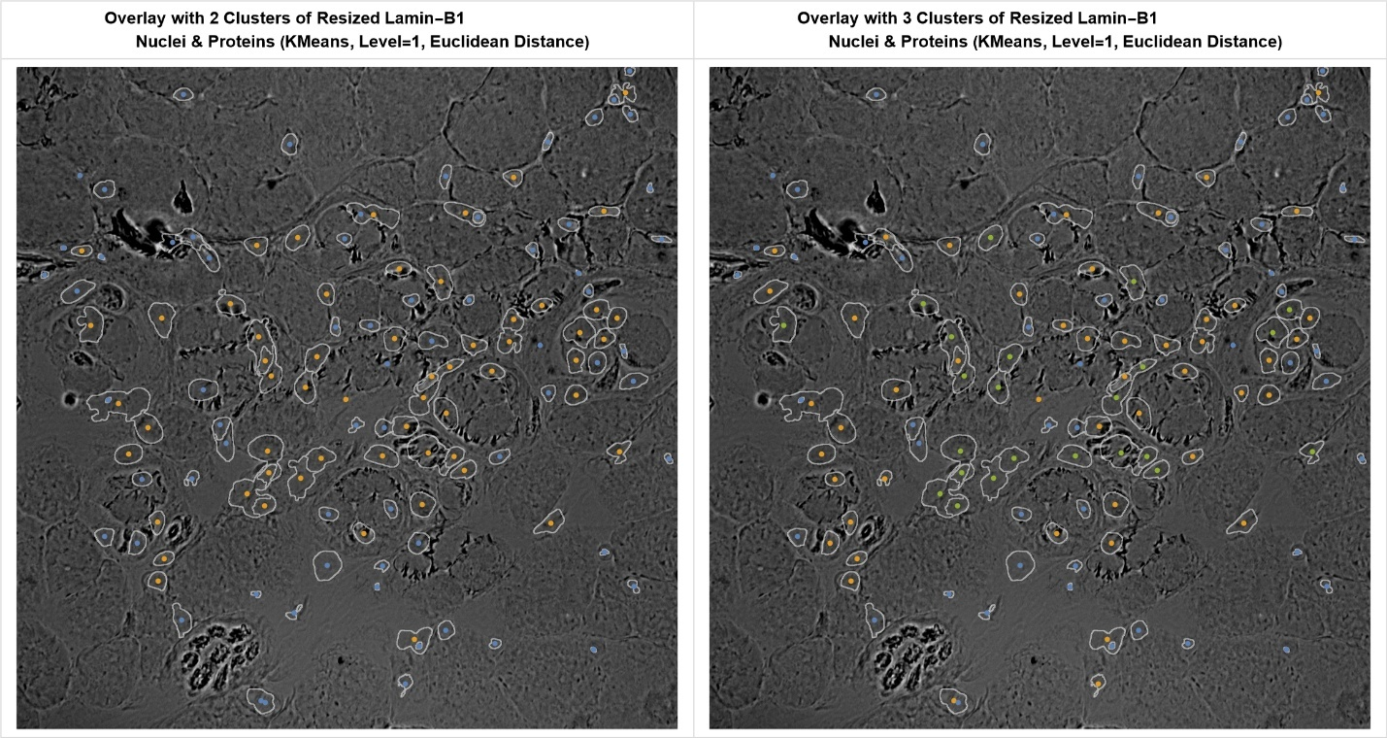

Appendix B - Overlays of Resized Nesprin-1 Proteins & Nuclei Segments
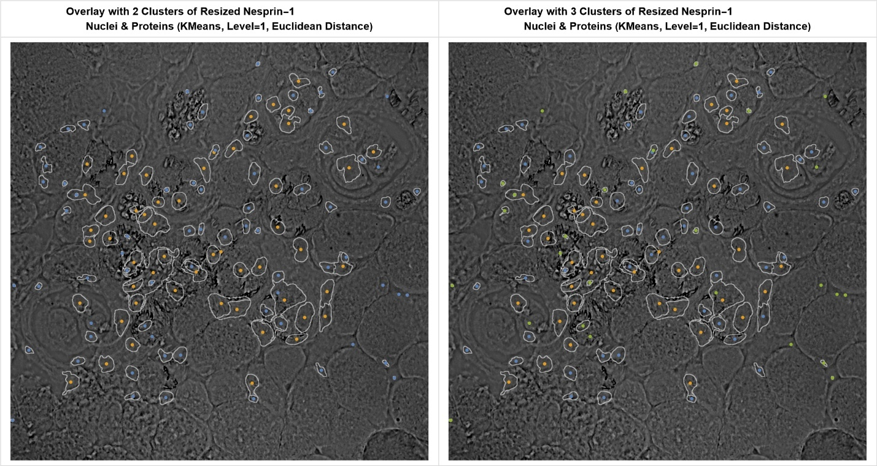

Appendix C – Software
Wolfram Mathematica was used because it easily integrates various image processing techniques, enabling rapid development and advanced visualization, making it the most efficient program for producing algorithms

Appendix D – Wolfram Mathematica Functions Used
HistogramTransform
HistogramTransform is a built-in function in Wolfram Mathematica that adjusts an image’s intensity distribution to match a specified histogram or to equalize contrast. It is commonly used to normalize lighting and improve visibility of features in images.

DimensionReduce
DimensionReduce reduces the dimensionality of datasets while preserving essential structure. It supports methods like PCA and t-SNE, and is used to project high-dimensional data into 2D or 3D for visualization or analysis

ClusteringComponents
ClusteringComponents partitions data into distinct clusters using unsupervised algorithms such as K-means. It returns component labels for each data point, allowing identification of similar groups based on feature similarity.

